 Database Review

Start by splitting the data in the Countries sheet using Excel’s Text-to-Columns tool. Choose the Delimited file type and select 'comma' as your delimiter.

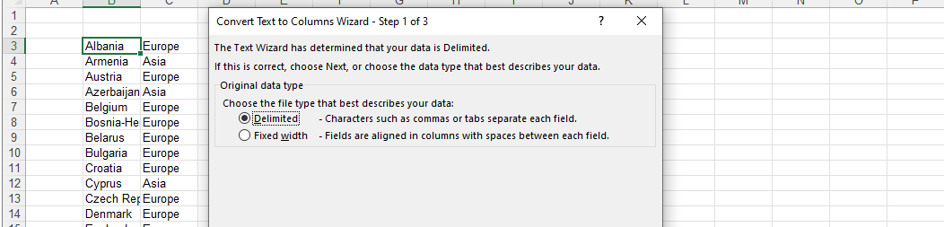

Next, clean up the continent names in the list by removing any extra spaces. Start by making a

copy of the list and then removing any duplicate values.

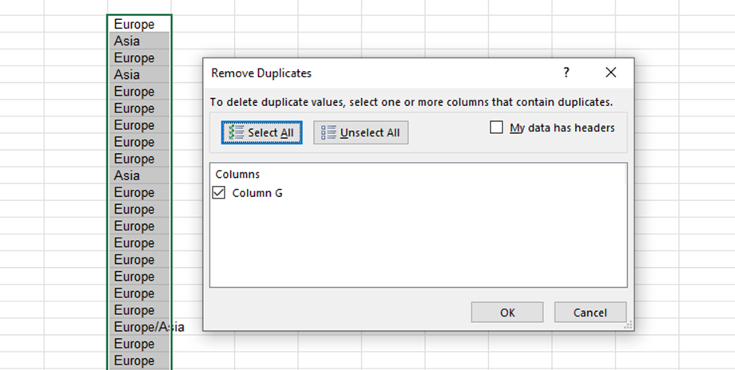

Use Excel's Find and Replace tool to remove spaces at the start of every continent name.

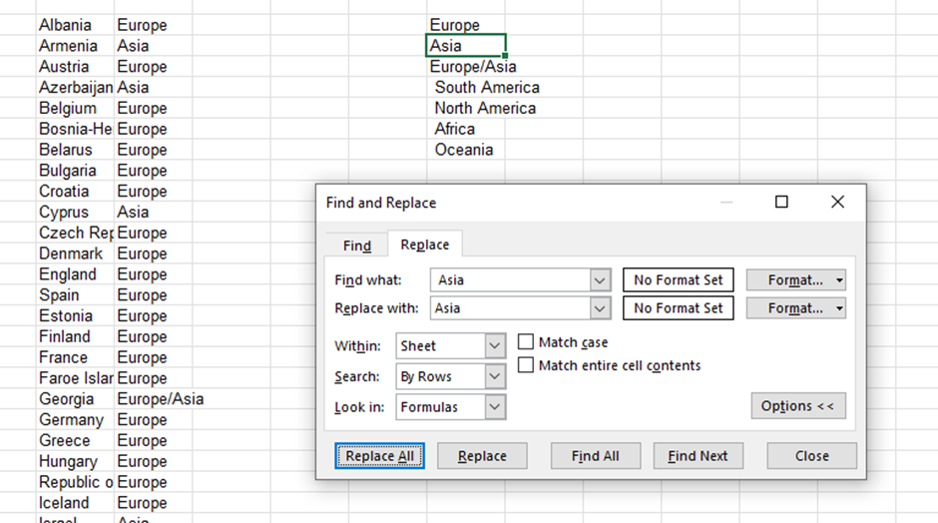

Now, switch to the Database sheet. Apply a filter at the top of the table and open the filter for the *Season* column.

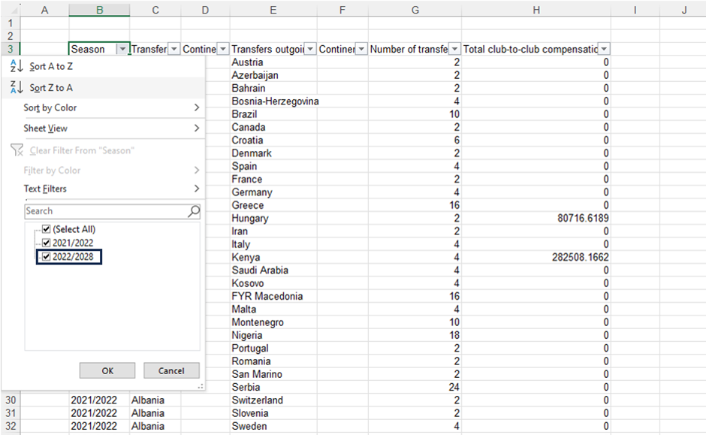

Look for entries that read 2022/2028 and replace 2028 with 2023 using Find and Replace.

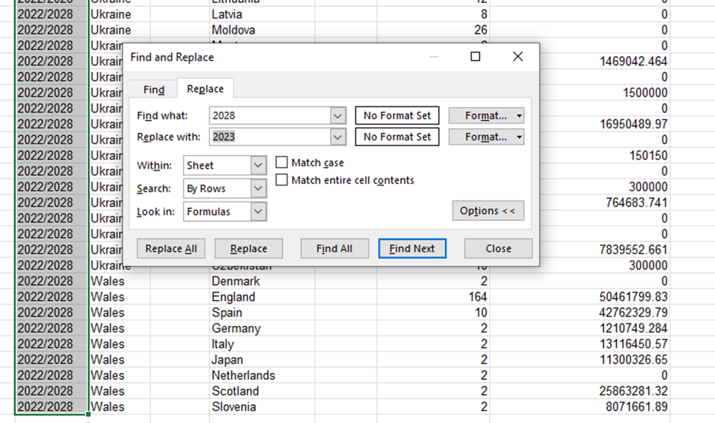

**Note:** Select the *Season* column before using Find and Replace. If you don't specify a range, Excel will make changes throughout the entire sheet, which could result in unintended changes.

Finally, fill in the *Continent* columns in the Database sheet. You can use Excel’s VLOOKUP or XLOOKUP function to do this.

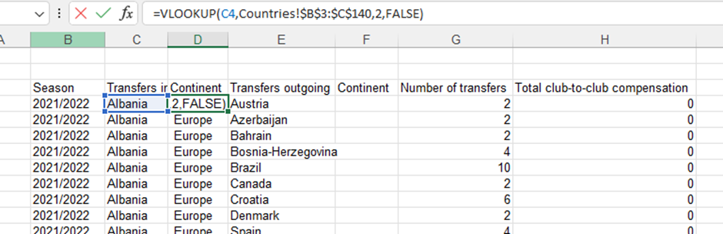

Football data Task 1.xlsx

**Part 2:** Analyze the Aggregate Number of European Transfers

For the project’s next phase, we'll need to create a table whose layout should look like the following:

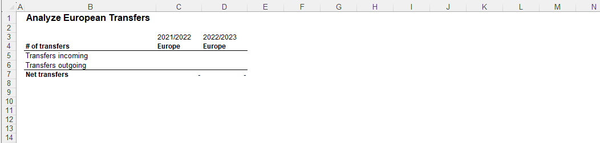

To populate this table, we'll use Excel’s SUMIFS function to add data based on multiple criteria. Our criteria include the following:

- The season (2021/2022 and 2022/2023)

- The continent (Europe)

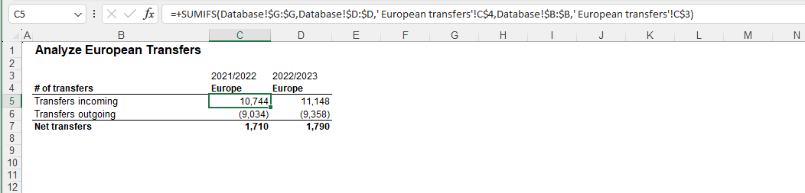

When filling in the 'Transfers outgoing' row, remember to 1) adjust the database column to correspond with outgoing transfers and 2) place a minus sign in front of the SUMIFS function. This will automatically convert outgoing transfers into negative numbers, making it easier to calculate the net movement of players.

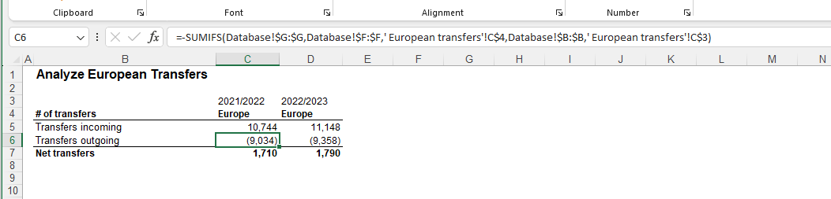

Football data Task 2.xlsx

**Part 3:** Analyze European Transfers by Country

In this portion of the project, we aim to construct a more comprehensive table. This table will illustrate the quantity and the financial worth of player transfers in and out of Europe.

First, we need to set up the structure of our table. After that, we'll use Excel’s SUMIFS function to fill it in.

Navigate to the Countries sheet and apply a filter specifically for European countries. Copy all European countries in the list:

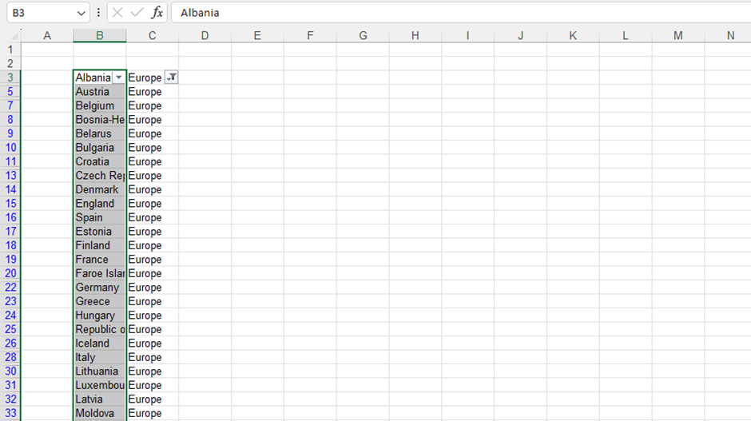

Create a new sheet called European Transfers by Country*.* The layout of the table should look like the following:

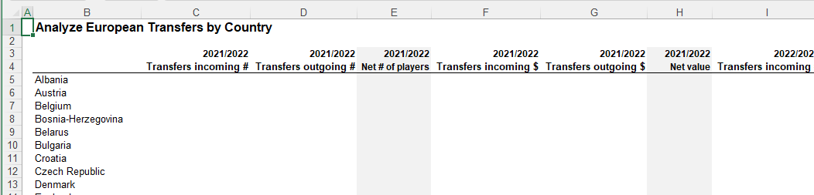

When setting up the SUMIFS function, remember how you fix the cell references. This way, you can reuse the function multiple times with ease.

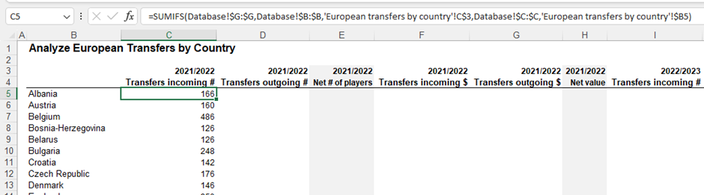

Remember that you'll need to tweak some parameters in the SUMIFS function when you're calculating outgoing transfers and working out the monetary value of transfers.

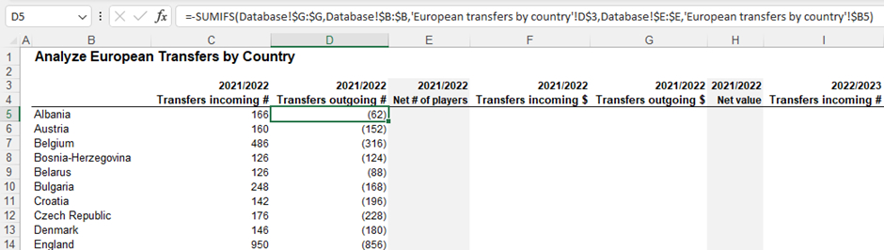

Include a minus sign for outgoing transfers, indicating that these transfers reduce the net inflow of players to a particular country.

Adjust the column to be summed accordingly when figuring out the monetary value.

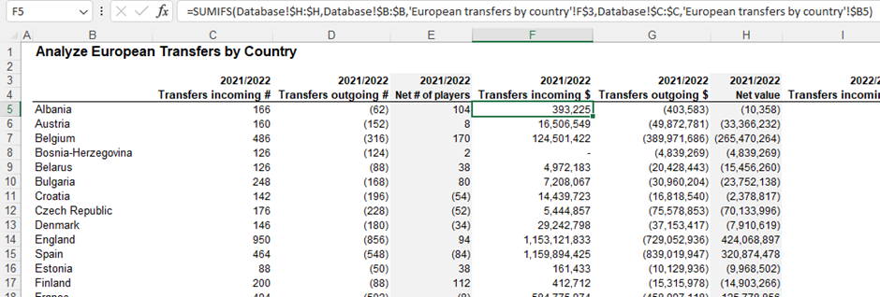

Once you've calculated all the 2021/2022 season figures, you can apply the exact formulas for the 2022/2023 season. Just paste them in.

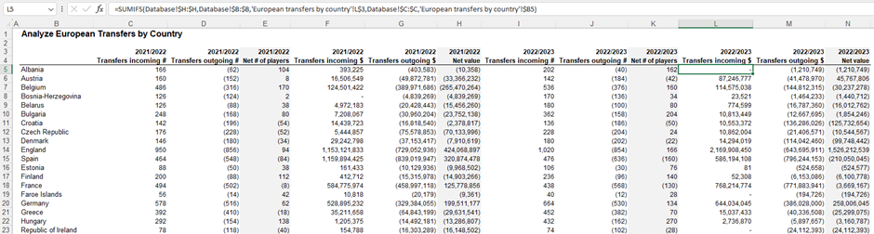

Football data Task 3.xlsx

**Part 4:** Visualize Transfer Fees of Top 5 European Countries

In the European Transfers by Country sheet, we'll use the RANK function to identify the five countries with the most significant incoming transfer values.

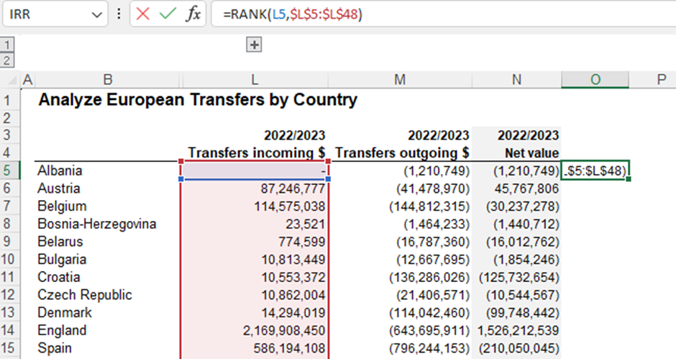

The RANK function needs the following two inputs:

Cell to be ranked

The range of cells it’s being ranked

Apply this formula to all cells, and we'll find our top spenders: England, Italy, France, Germany, and Spain.

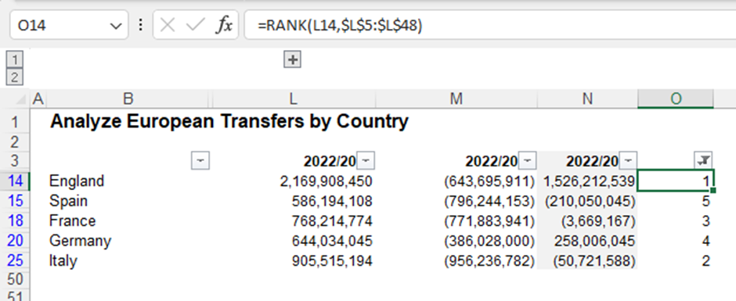

Next, we'll organize our data for visualization. Create a new sheet named Visualization Top 5 Countries. Set up a table that needs to be filled in.

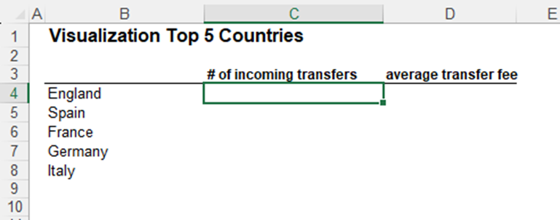

We can fill this table in using Excel formulas. To get the number of incoming transfers for each country, use a simple SUMIF function. To calculate the average transfer fee, divide the total value of incoming transfers by the number of transfers.

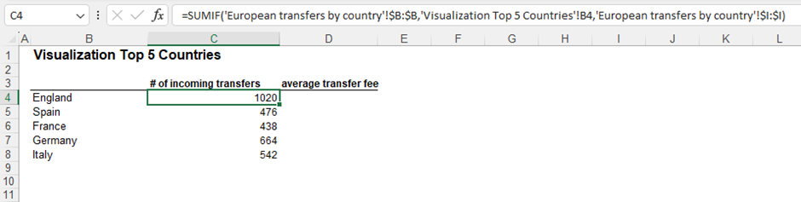

To calculate the average transfer fee, divide the total value of incoming transfers by the number of transfers.

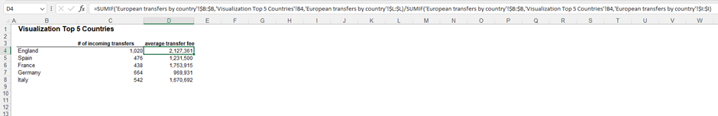

This data shows that English clubs lead the pack in volume and cost, spending more than $2 million on average per transfer.

Let’s create the visualization required.

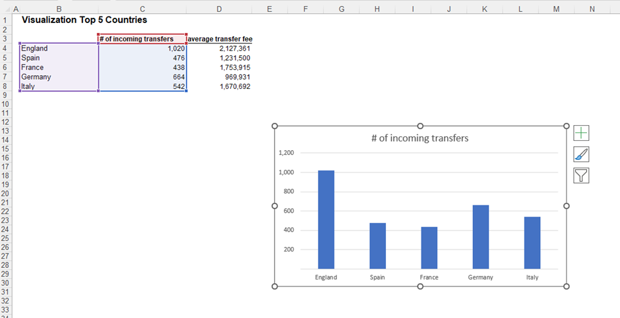

Then you can drag the ‘average transfer fee’data to add it to the chart.

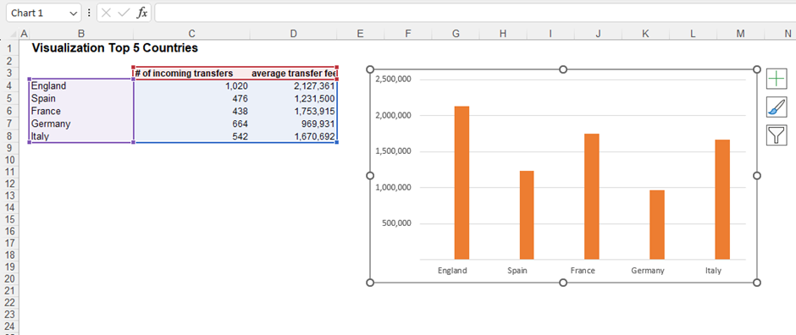

Because the two variables have different scales, the ‘average transfer fee’ completely dwarfs the ‘# of incoming transfers,’ so we need to add a secondary axis that shows ‘average transfer fees’per country separately.

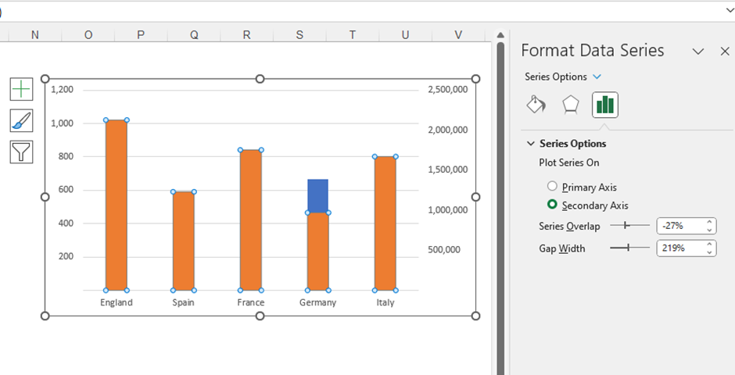

Once we’ve opted for the secondary axis, we can change the chart type and choose Line.

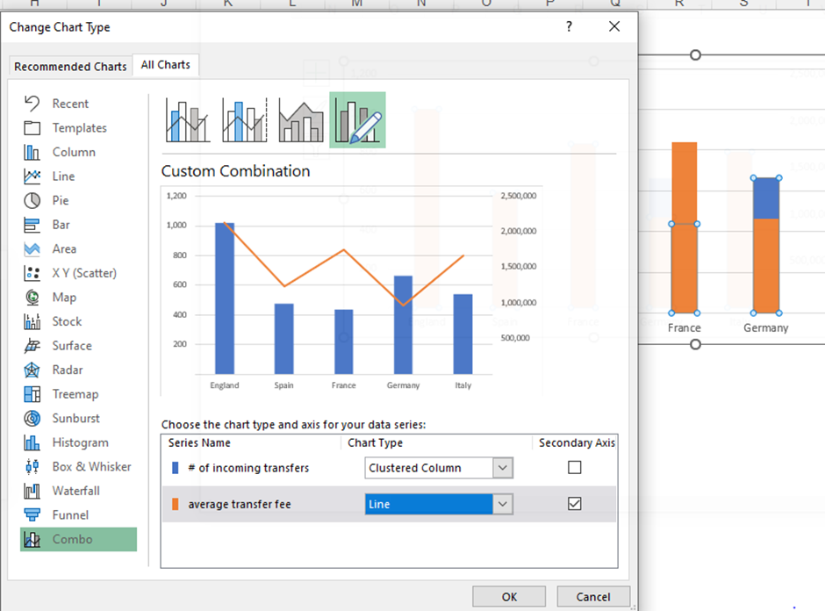

The formatting touches I would perform on this chart include the following:

Change font and font size

Add transparent background (no fill)

Remove the borderline

Adjust the gap width from 219% to 70%.

Change the color of the two series in the chart

Smooth line

Add a meaningful title and axis titles

